Insulin Sensitivity Factor ISF
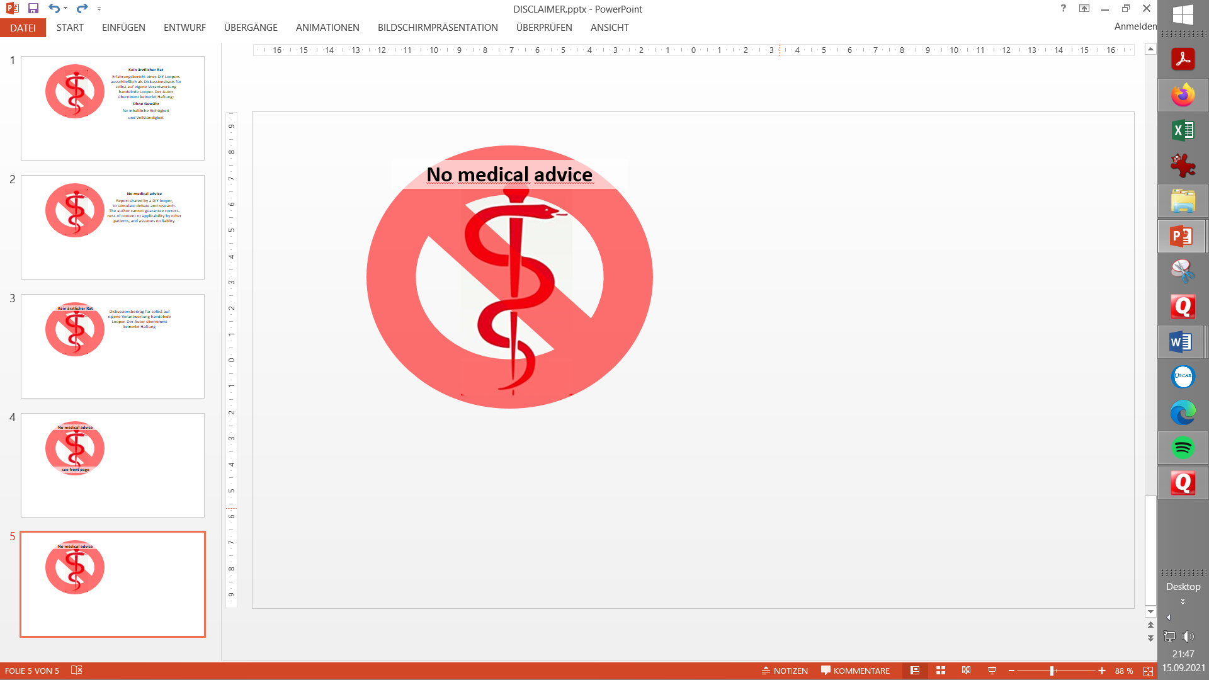
Contribution to the discussion among DIY loopers
The author assumes no liability V.4.0
- What is ISF
- Rough estimates for your ISF
- „Experimental“ determination of (CRR and) ISF
- Nighttime ISF?
- How the (oref) algorithm uses ISF
- Options to deal with variability of ISF
- 6.1 Circadian profile_ISF
- 6.2 Manual adjustments
- 6.3 Automation-based adjustments
- 6.4 Autosens
- 6.5 Activity Monitor
- 6.6 Autotune?
- 6.7 „Self-learning systems“
- 6.8 DynamicISF („logarithmic”, original TDD based concept)
- 6.9 Sigmoid dynamic ISF
- 6.10 autoISF
7. Tuning ISF in closed loop
- 7.1 Signs of a wrong ISF
- 7.2 Differential diagnosis occlusion
- 7.3 Understanding tuning options (Excel tool for dynamicISF, sigmoid and autoISF)
- 7.4 Avoiding hypos after meals from “tails” of insulin activity
8. Remarks regarding (ISF and) Full Closed Looping
Note that this paper is written by someone with much more experience with oref loops (AAPS, Trio, iAPS) than with iOS Loop, which therefore is not in all aspects as well covered. It combines material for novices and for experienced users. Best only jump into chapters of interest to you. Give yourself time to eventually revisit, or to dig deeper with given links.
- What is a ISF?
Your insulin sensitivity factor (unit: (mg/dl)/U or (mmol/l)/U) says how sensitive you react to insulin, so how much your glucose level will come down per unit of insulin .
For instance, ISF = 30 (mg/dl)/U means, per unit of insulin our glucose level goes down 30 mg/dl. For mmol, divide by 18: ISF = 30/18 = 1.7 (mmol/l)/U
- Rough estimates for your ISF

2.1… using Autotune (not recommended by the author)
Autotune (in oref loops) gives you ONE „average“ ISF. Reliability of this result is seen controversially in the looper community, largely, because Autotune relies on your data inputs which probably contain errors (like your carb inputs). Also there is no use to Autotune when you are using dynamic ISF adaptations (dynamicISF, autoISF).
See also: https://androidaps.readthedocs.io/en/latest/Usage/autotune.html
and https://github.com/bernie4375/HCL-Meal-Mgt.-ISF-and-IC-settings/blob/HCL-.-settings-main-repo-(pdf)/Using%20Autotune_V.1.pdf
2.2… via daily total insulin dose, TDD
The daily total insulin need describes, roughly, the insulin sensitivity of a type1 diabetic. The following table reflects values seen in a big study.
Example: At 35 – 40 units of daily insulin (mid of left column) an ISF of around 45 mg/dl/U (35-60) would be suspected, or around 2.6 mmol/l/U
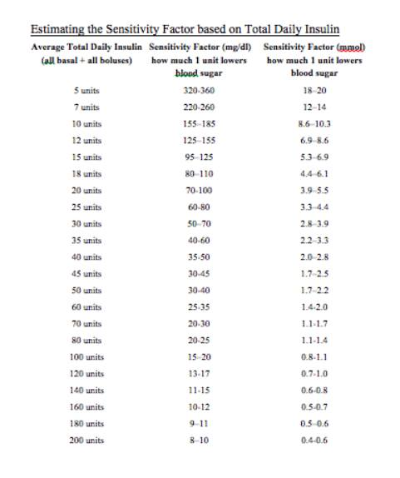

  - Estimate using the „1700“ rule
According to a study https://www.ncbi.nlm.nih.gov/pmc/articles/PMC4454102/ the ISF can be estimated using:
ISF=1700 / TDD (or = 94.4 / TDD for mmol)
where TDD is the total daily insulin, determined for each virtual patient, and assuming an average diet of 180 g of carbs for adolescents and adults, and 135 g for children.
Example as above, 35…40 U TDD: ISF = 49 … 42 mg/dl/U (divide by 18 for mmol)

- Determination of Carb Rise Ratio CRR and Insulin-Sensitivity Factor ISF
Basal rate first
Verify that you have a correct basal rate before determining factors!
Else your ISF will have to balance errors in your hourly basal pattern, and you may lose some of the principal power of your loop.
Helpful links regarding basal rate
- A basal rate helper, drawing data from your Nightscout site (by Peter van Rijt): https://www.nightscoutsuggestions.com/index.php
- a good article in support of that process: https://www.mysugr.com/en/blog/basal-rate-testing/
- a process description by a commercial service, including a tool : https://www.mevita.de/.../online-zugang-erstellung-einer.../
Although I advise to determine your true, likely circadian, basal rate: It can be „good enough“, and advantageous especially for small kids, to simplify things and assume a (in case of doubt, low) flat basal rate, together with a well-contoured ISF pattern („with enough bite where it counts“). Discussions on this topic can be found in looper sites using the search term “flat basal rate”, or here: https://www.diabettech.com/basal/basal-testing-single-basal-rate-variable-isf-and-cr-feedback/
Interpret enthusiastic reports on flat basal with caution, though. Positive observed effects are likely coming from significantly increased attention to ISF … and this brings us back to our topic …
Start your ISF test with a CRR determination
To determine ISF, select a day without prior strenuous exercise/activity, without exceptional stress, or infection.
As testing for ISF must start out with a high plateau of glucose level, it makes a lot of sense to do a determination of your CarbRiseRatio CRR first:
(In a relatively stable, normo-glycemic phase) take a sweet drink with a known carb content, and watch (in Open Loop, not giving any insulin except profile basal rate) by how many (mg/dl) glucose rises, until reaching a plateau (in about 1 hour).

Example: After consuming 20g, my glucose rises from 90 to 190 mg/dl.
CRR = (190-90)mg/dl / 20g = 5 mg/dl / g
ISF determination
Now, having reached a high plateau – at 190 mg/dl in our example ,-we move on to “experimentally” determine the ISF.
Inject (still in Open Loop, with profile basal running), an amount of insulin as you typically would (considering your personal insulin sensitivity). Example: 2 units
Caution: For a kid you would use much less than 2 U: Think about typical correction boli in the past, or use your “suspected” ISF (if it is over 100 mg/dl/U then you definitely should stay under 1.0 U)..
Then watch for about three hours until a deeper plateau is reached, for example at 110 mg/dl. Then you can evaluate:
Example: 2 U of insulin lowered my glucose by 80 mg/dl . Hence, ISF = 40 mg/dl / U

Off topic remark: Using CRR and ISF you can also calculate your carb ratio (IC, CIR) for this time of day, or check the plausibility of the carb ratio you are already using, because:
ISF (mg/dl decrease per unit of insulin) / CRR (mg/dl increase per g of carb) = IC (g carb per unit of insulin) (similar in mmol) or also: CRR = ISF / IC
Carb ratio in the example from above: ISF / CRR = 40 (mg/dl)/U / 5 (mg/dl)/g = 8 g/U = IC
The CRR is relatively stable (does not vary by much over 24 hours):
- while both ISF and IC do vary (in similar ways, related to your insulin sensitivity)
- if you divide one by the other, deviations owed to sensitivity cancel out.

- Nighttime ISFs
The sleep period should be easiest for the loop, with bg steadily approaching target after the “disturbances” from your past day, notably the dinner. One of the great, and fairly easy-to-reach, benefits of looping therefore is, to get into each new day at a glucose value near target.
I like to use nautical analogies (as you might know from my meal management series): It is by far easier to navigate a sluggish control system coming from a nearly straight line, and keeping the eye on the target, than to roller-coaster into a new adventure!
In case your nightly bg curve is not showing the expected performance:
- If it stays extremely long above target, consider making nighttime ISFs more aggressive (lower)
How much more aggressive can be estimated from your data. Example: 1) You received 4 U between 11pm and 3 am 2) You would likwe to be by 40 mg/dl lower by ~ 3am 3) 40 mg/dl divided by your “old”ISF of 40 mg/dl/U => you wish you had received additionally 40 / 40 = 1 U 4) 5 U / 4 U = 25% more insulin 5) To get 25% more, your new ISF must be lower: ISF_new = ISF_old / (1 + 25%) = 32 mg/dl/U
- If it goes below target (and stays there, or oscillates, with hypo danger, make nighttime ISFs less aggressive (higher).
How much less aggressive can be estimated from your data. Example: 1) You received 4 U between 11pm and 3 am 2) You took 12 g anti-hypo snack at 3 am, and noticed (via getting 0.5 U above profile basal in the next two hours) that that was 4 g too much. 8 g really needed corresponds to 1 U too much insulin at a carb ratio of 8g/U. ~ 3) => you wish you had received 3 U instead of 4 U between 11 pm and 3 am, or 25% less. 4) To get 25% less, your new ISF must be higher: ISF_new = ISF_old / (1 -25%) = 53.3 mg/dl/U
- Experiment with “quieting down” your loop’s aggressiveness in certain night hours via shutting off SMBs (AAPS Preferences: No SMBs at elevated bg target (or at odd-numbered target); set such target for those night hours)
- If you still find problems (e.g. in nights after a late fatty pizza), analyze your data pattern and define an Automation. (My pizza Automation is to pause the SMB shut-off for a couple of minutes (= 2 SMBs) whenever certain bg, delta, and iob “pattern” is seen).
- On days with strongly changed insulin sensitivity (e.g. after a day of sports), operate at a % adjusted temporary profile during the night.
Note that before optimizing ISF you must be sure that your profile basal for the night hours is about right, and the DIA for your insulin is not set too short.

- How the (oref) algorithm uses ISF

The loop always has a very precise picture regarding how much insulin is consumed in every 5 minute segment (and even how this continues, based on iob, and on when each of the contributing microboli were given).
Example: We saw 0.7 U used up.
Every 5 minutes, after a new CGM value came in, the algorithm sees the delta.
The observed change in bg (bg delta) divided by ISF is the amount of insulin used up for the observed bg correction (e.g. at an ISF of 40 mg/dl/U, when we see bg lowered by 20 mg/dl: 20 mg/dl divided by 40 mg/dl/U = 0.5 U)
The remainder of iob consumed ( 0.7 – 0.5 = 0.2 U in our example) multiplied with the IC is the amount of carbs absorbed (e.g for someone with an IC = 10 g/U: 0.2 U times 10 g/U = = 2 g ).
In our example (0,7 U delta iob in 5 minutes, bg falling by 20 mg/dl and at assumed IC and ISF), 2 g of carbs were absorbed in 5 minutes. (This would be 24 g/hour, a very reasonable value).
So, we see ISF plays a role in calculating carb absorption (more discussed in the paper on “Carb ratio…pdf” in Github/Bernie4375/HCL
Unlogical effects are preferably assigned to temp. changes of your insulin sensitivity, and can also be pro-tractred into predicting what is expected to happen in the next couple of 5 minute segments. This brings us to our next topic:
The algo always assumes the carb absorption that “pro forma” (in the afore-mentioned calculations) resulted in the past 5 minutes, is likely to continue, then could slowly fade out, over the next hour or so …
Background: 1) It is not possible that our digestion all of a sudden stops; it either is in a rise phase still, or at a constant “burn” level, or at a – likely a S shape – decline. 2) Your given e-Carb or FPU input might suggest less “fading out”, and this will go into one of the predictions. However, knowing how uncertain user inputs about grams of carbs coming to be absorbed in later hours after meal start are, the oref loops will put higher emphasis on the UAM calculation driven prediction (and, in UAM FCL, fully rely on it).
Note that, always 5 minutes later, the loop can see how it really went, and adjust again. This "touch and go" will very often be better than what you could attempt to tell your loop about exact grams, and when they actually will be digested.

- Options to deal with variability of ISF
Unfortunately, our ISF is not a constant.
Our insulin sensitivity is influenced by many factors, 42 of them according to: https://github.com/bernie4375/HCL-Meal-Mgt.-ISF-and-IC-settings/blob/HCL-.-settings-main-repo-(pdf)/42%20factors%20influence%20bg.pdf .
There are many ways to deal with that variability.
One easy way is to say, it is anyways pretty chaotic overall, and my loop re-analyzes every 5 minutes. So I just employ dynamicISF and sit the situation out (at for me good-enough %TIR resulting on average).
But this paper mainly is about the many options to really accept the challenges, and
- ever better understand, and co-manage with your loop
- gain better %TIR with greater degree of freedom to do even extreme things (exercise, meals …)
Please apply caution if you combine some of the discussed methods, as they probably work in the same direction, and could „over-adjust“ your ISFs (especially if not tuned properly together).
6.1 Circadian pattern of ISF
ISF varies over 24 hours according to a „circadian“ pattern of varying sensitivity to insulin.
See AndroidAPS Users / Files / ..circadian … Duesterhöft.xls: https://www.facebook.com/groups/AndroidAPSUsers/permalink/2869638923257506/
Example
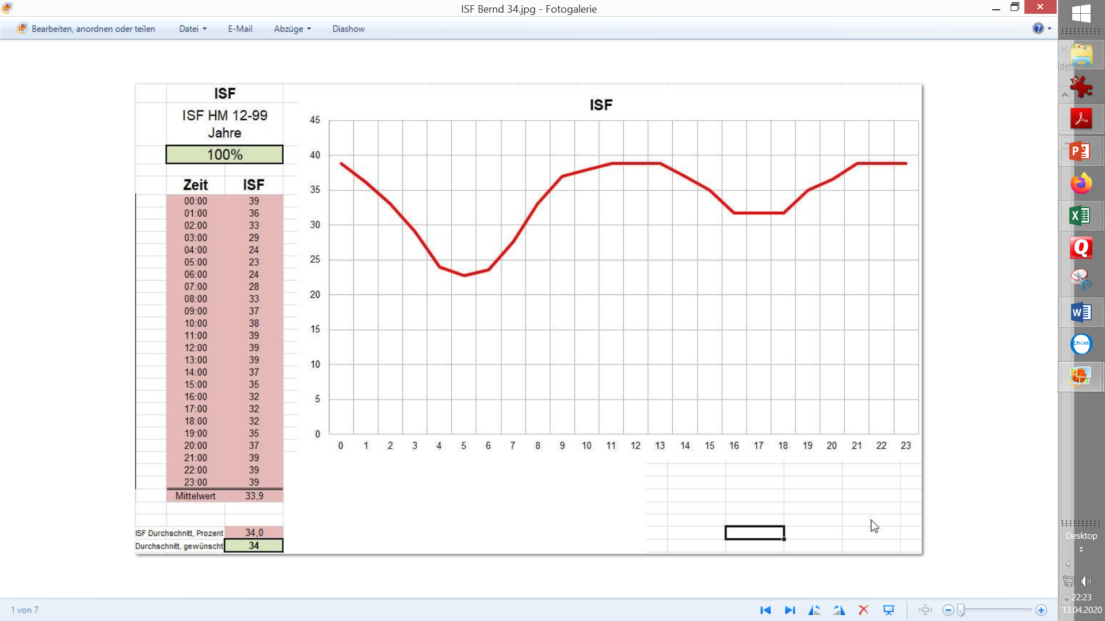
Do not just copy a pattern that may be valid on average for T1Ds out there, or for a single other person! For instance, I am more of a night owl, so that curve shifts 1-2 hours to the right.Likewise, if you do shift work or cross-time-zone travel, keep an eye on your (probably time-delayed) adjustments of your body‘s insulin sensitivity.
The deepest dip in ISF, and highest hill in hourly basal, is typically an hour or twao before getting up and breakfast. However, I usually skip breakfast, so I „break my fasting“ (!) for lunch and see higher insulin sensitivity there than the standard curve suggests. (Another explanation could be, that others would have tail of insulin sensitivity from breakfast still at work supporting insulin for lunch (with a typical breakfast, low in fat and protein).
In case you work with a flat basal rate, your ISF should look even more „contoured“: For instance, if you use your low hourly basal, as approriate in most night hours, for all 24 hours, the daytime ISFs would need to be make up for „deficiencies“ in your hourly basal; likely morning and evening ISFs would dip relatively lower even than in picture on preceding page. YDMV!
So, determine your ISF for a couple of times, in which you find high values which your loop needs to regulate down (one of them, inconveniently, probably being after midnight; see also 2 sections lower).
You can interpolate for the hours for which you did not „experimentally determine“ your ISF. Follow the idea (or data) you have regarding your general pattern of insulin sensitivity.
Caution regarding kids
For kids, the 24 hour sensitivity patterns can differ strongly from adults and can also change strongly in certain growth phases, see the following graph (shared by „basal rate guru“ Heiko Mueller, www.mevita.com)
To help “construct” a circadian profile for kids, there is a “profile helper” in AAPS: https://androidaps.readthedocs.io/en/latest/Configuration/profilehelper.html#profile-for-kids-up-to-18-years
The following graph shows typical circadian patterns for basal rates, and is normalized to 100% being the total daily basal.
So, the graph below says how much %of the daily total is needed in every hour of the day. It does NOT show the very significant differences in basal insulin need between the age groups! We are looking only on the 24 hr patterns here!
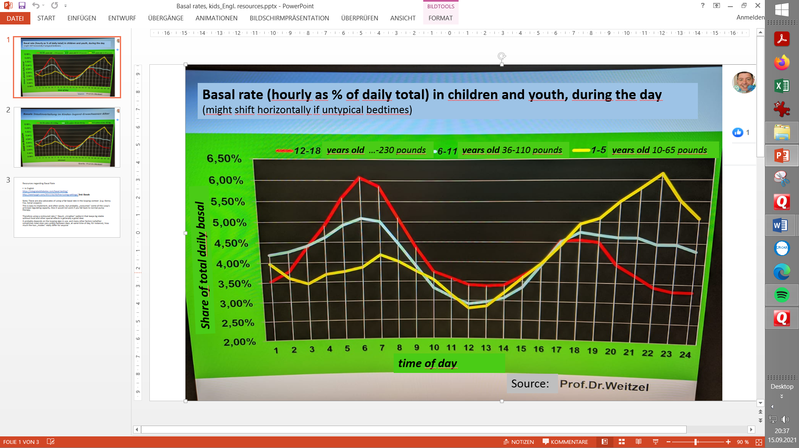
The graph is for basal pattern.
For ISF the curve would look „opposite“ (~mirrored on x-axis), because higher basal („mountain“) = lower insulin sensitivity = higher insulin need = lower ISF factor („valley“). For the red curve (age 12-18 resembles adults fairly well already) we see this mirrored pattern beautifully in the ISF graph, 2 pictures higher up.

6.2 Manual adjustments to temporary higher or lower insulin sensitivity
All DIY loops allow manual adjustments of ISF in use … setting temp.%profile e.g <100% for exercise, or >100% in sickness.

In AAPS, this is easy done via inputting a temp.%profile change via the top left button on the AAPS main screen.

  - Automated adjustments for short-time „boost“ of ISF (in AndroidAPS also via Automation)
Often a short phase of insulin resistance is encountered, for instance a few hours after a fatty meal. Insulin seems to have lost it‘s potency for 1 or 2 hours. This is often assigned to receptors blocked by free fatty acids, and requires extra insulin – but only for a very limited time, until the receptors are cleared -.
Rather than taking care of this phenomenon by giving an extra manual bolus, AndroidAPS allows an elegant automated solution for this problem: When conditions like glucose above 180 mg/dl (and others, like iob thresholds, time of day where the problem is likely etc) are fulfilled, a more aggressive ISF can be programmed into an Automation (for example, by setting 130% profile (‚override‘) for 8 minutes), and automatically be applied when the conditions are given..
Such automations are technically very easy to „program“, but require attention to one’s own daily patterns, to define a truely personalized problem solution.
Details see for example at https://androidaps.readthedocs.io/de/latest/Usage/FullClosedLoop.html#stagnation-at-high-bg-values
  - Autosens
If in absence of carbs, the loop finds discrepancies, that your “old” ISF Cannot explain the bg delta seen, at the objectively clear insulin that was used up => Autosens concludes higher insulin sensitivity or resistance%, and this can be automatically translated into ISF modulations.
Typically, data for this are based on the last 8 … 24 hours (look up details in readthedocs for your system, for AAPS here: https://androidaps.readthedocs.io/en/latest/DailyLifeWithAaps/KeyAapsFeatures.html#enable-autosens-feature
In conclusion, this method adjusts not in a very reactive fashion, but can be good for “long waved” (> half a day) sensitivity changes you may have.

  - Activity Monitor
Compared to Autosens, this is a more reactive adjustment method that is based on the last 1 hour of data from your phone’s motion sensor. But it is limited to motion-related sensitivity effects.
In autoISF this is incorporated in a fashion so the user can independently tune ISF more aggressive for desk or couch, and less aggressive for moving around.
More see: 6.6 Activity Monitor in “06_Exercise …pdf” at: https://github.com/bernie4375/FCL-potential-autoISF/blob/FCL-e-book

  - Autotune
You are unlikely to benefit (as already argued in 2.1).
Please refer to “Autotune…pdf” in: https://github.com/bernie4375/HCL-Meal-Mgt.-ISF-and-IC-settings/blob/HCL-.-settings-main-repo-(pdf)/Using%20Autotune_V.1.pdf

  - „Self-learning systems“
There are commercial systems that do not require inputting ISF. Manufacturers usually do not disclose details about the underlying algorithm, but we must expect something like dynamicISF (see next section), maybe combined with some machine learning along the lines of what Autotune (section 6.6) does.
They typically target 80%TIR. For that it is proven that it can work well enough, and it relieves users of the “pain” to learn about their loops and occasionally analyze their data.

6.8 DynamicISF („logarithmic, original TDD based concept)
6.8.1 Using a dynamicISF derived from bg value and TDD: The 277,700 rule
It has been suggested
- https://www.facebook.com/groups/TheLoopedGroup/posts/2996545667228746/ and https://youtu.be/oL49FhOts3c / Chris Wilson / see also in Loop&LearnFB)
that the ISFs can be dynamically modelled using the formula:
ISF= 277 700 / (TDD * bg) (or = 15 428 / (TDD * bg) for mmol)
The formula is derived from real-life data of non-looping insulin-dependent diabetics.
It resembles a combination of the “1700 rule” we saw in section 2.3 and the TDD effects used in section 2.2 for rough ISF estimates.
Overall, it seems like a good rule-of-thumb for MDI patients, who give shots against often super high bg. When looping, it is not ideal to be more aggressive when bg is very high. Ideally, at bg peak the loop zero-temps …
To resolve some issues (that were also seen in practice), the dynamicISF we now find integrated in looping systems was conceptually refined.

6.8.2 Refined dynamicISF variants
Plug-ins are available for both, AndroidAPS (by Tim Street), and also of Trio and iAPS. To overcome major problems with the rough first approach (above ISF formula, to put it bluntly, was based on “wild” data from how “real average diabetics jerk around with their super high glucose values”), the formula has been significantly refined, and also was made user-tuneable.
Key improvements were
1) to allow to shorten the used observation period for TDD (towards the magnitude used also in Autosens; see also: https://androidaps.readthedocs.io/en/latest/DailyLifeWithAaps/DynamicISF.html#enable-tdd-based-sensitivity-ratio-for-basal-and-glucose-target-modification)
2) not just use bg, but (also, in various degrees) strongly consider predicted bg (details for AAPS see: https://androidaps.readthedocs.io/en/latest/DailyLifeWithAaps/DynamicISF.html#future-isf) and for Trio: see here: https://open-iaps-docs.readthedocs.io/en/latest/settings/configuration/concepts/autosens-dynamic.html#advanced-information and here: https://diy-trio.org/videos/v/everything-to-sell-anything-427ge-t8t94-ys9pb-p8b9h
* At high bg plateaus, this feature helps “tune down” the ISF used as the high begins to resolve, as seen by lowering predicted (also called “eventual”) bg values. This helps prevent hypos later.
* This concvept looks superior to other modes of modulating ISFs that really strictly build on actual bg. But it is really not (I see it rather as a (good) patch to an inherent problem in log dynamicISF): Other modes, notably sigmoid dynamic ISF and also autoISF, also work with predicted bg, but only when defining insulinRequired, while the strenghth of the ISF applied in this calculation anchors on current bg (…which seems logical, because why should an ISF be influenced by a future bg situation?).
3) most (all?) variants come with a user setting ( in AAPS called “dynamicisf adjustment factor% ( 1… 300%) that multiply with the divisor in the dynamicISF formula. For example: 1/ 200% halves the dynamicISF = makes it double as aggressive, while 67% would in effect only deliver 2/3 of the insulin).
Tuning dynamic ISF (if you use that plug-in) relieves you of “the pain” to define your ISF profile. However, it requires complex different considerations:
- Look up in your data which part of the “dynamic range” of ISFs resulting from the used formula is actually in use to correct your glucoses, and how to influence that via your tuning.
- Try to find your adjustment factor that provides the best balance of solutions to the problems you see at different glucose levels, in your looping data.
- Refer to different resources, e.g. subsheet bg, dyn in: https://github.com/bernie4375/FCL-potential-autoISF/blob/FCL-e-book/04_ISF_weight_effects_V.7%2C2.xlsx

DynamicISF may be the easiest way (with just 1 tuneable factor) to arrive at ISFs that by and large work well for you.
But generally a combination of carefully set ISF profile, plus using tools to adjust for temp. insulin sensitivity “swings”, can provide the “best tailored” solution, needed:
- if you strive for best-possible %TIR in your Hybrid Closed Loop
- if you intend at some point to go Full Closed Loop (no bolus, no carb inputs).
6.9 Sigmoid dynamic ISF
Sigmoid is a dynamicISF variant that does no longer fully de-couple from the user’s profileISF, and also it does not rely on TDD.
See subsheet bg, dyn in: https://github.com/bernie4375/FCL-potential-autoISF/blob/FCL-e-book/04_ISF_weight_effects_V.7%2C2.xlsx

6.10 autoISF
autoISF (available only in oref loops) is also anchored on (ideally, experimentally determined) profileISFs.
The method is sketched in subsheet “auto” in https://github.com/bernie4375/FCL-potential-autoISF/blob/FCL-e-book/04_ISF_weight_effects_V.7%2C2.xlsx
If working with a smooth CGM and the complex tuning is done right (based on your personal data), autoISF should outperform most if not all other methods. It is extremely real-time reactive to changing insulin requirements, whiuch is essential for Full Closed Looping.
autoISF allows very “tailored” modulation, notably boosting, of your profile ISFs, to adjust them further for optimal management, depending on;
1) Glucose plateau (how high glucose is, and for how long it is that high already) =. “elegant” tool for resolving “stuck high bg” while limiting hypo danger later.
2) Glucose level = sharpen ISF at high glucose levels (not used much in FCL because it is kind of late to react then)
3) Glucose delta = sharpen ISF when glucose rises strongly.
4) Acceleration of glucose rise (strongest ISF as soon as a meal-related rise is detected, and weaker ISF – already during the glucose rise! - after curve bends around heading towards a peak). = This is extremely helpful in UAM Full Closed Looping, but requires a smoothly operating CGM, so what the sophisticated math makes of your glucose curve, to fire off strongly boosted SMBs, is not just a temporary artefact.
Any of these 4 autoISF varieties can (must) be tuned separately, but also can interfere with eachother and with Autosens. For more details see https://github.com/bernie4375/FCL-potential-autoISF/blob/FCL-e-book/04_ISF_weight_effects_V.7%2C2.xlsx (and other parts of the FCL-e-book there).
- Tuning ISFs when looping

7.1 Signs for a wrong ISF
If your ISF is too strong (in other words the actual number is too low compared to reality of your real insulin sensitivity), one of the most common symptoms you’ll see in closed-looping is a roller coaster of glucose values, and the temporary basals might be cycling between zero and high temping.
If ISF is too weak, the glucose is not corrected down to target (or this happens only extremely slowly).
If you observe such behaviour in certain time periods of your day, you might consider changing the ISF by plus 10-20% (if ISF seemed too strong) or by minus 10-20% (if ISF seemed too weak), and see (with alarms set on loud), whether the situation improves next day.
See also https://diy-trio.org/start-up-guide-1-1

7.2 „Differential-diagnosis“ occlusion when dealing with high glucose values
When we encounter high glucose values it is very important, as a first step, to exclude a compromised insulin delivery as underlying cause.
This problem can mimick an increased insulin resistance, and there are loopers who for instance let their dynamicISF run against that. I like to compare that with driving a car with transmission defects. Yes, possible for a while and in certain terrain. But I strongly advise not to operate with counter-.errors to balance a problem, but to solve it (and work with “true” data, and full dynamic regulating capability, of the loop),
Users of Lyumjev or of Fiasp seem to experience occlusions quite often, especially if not changing cannula frequently. Under the skin, near the insulin insertion site, partial or full blockages can occur and insulin is being pushed back out into the adhesive patch of the cannula. This results in glucose rising despite (fake) high iob.
In such instances, loop should be switched off. The share of insulin that did not effectively enter the body system must be estimated (conservatively, in case of doubt), and erased (in AAPS: Treatments tab/Bolus/erase a number of entries there), so a realistic iob number is there for the loop to continue .The occlusion must be resolved (usually by setting a new cannula) , and the high glucose must be treated. As your iob estimate is likely uncertain, do this conservatively, and continue in closed loop with alarms set on loud .
In case the high values were realized only after a couple of hours, watch out for signs of Keto-Acidosis and be ready to follow a treatment scheme for it. Hospitalization may be required.
Off Topic: Also fake high cob can happen. This would develop after throwing up shortly after a meal which you bolussed for. You could remove carb entries in your loop for correct carb data.. But the loop (nor you) cannot remove insulin from the body, and glucose snacks etc.- which are needed in significant quantity quickly now - , likely are also thrown up. A glucagon injection may be needed.
Caution: To stop more insulin delivery, and erase false cob, is by far not sufficient to resolve this crisis. This is an emergency with extremely high hypo danger at the rapidly approaching point of time, when your meal bolus reaches maximum activity! Call for emergency: * if you can’t eat/drink (or not keep it in) * if you go below a certain glucose value that you laid out for yourself when still clear in the head. (It probably would be too complicated to build a strategy on the 5-minute delta glucose values, and amount of carbs you were successfully taking)
Especially users of Lyumjev or Fiasp should be aware how fast glucose can sink in absence of sufficient carbs for the iob that is present.!

7.3 Understanding tuning options for dynamicISF, sigmoid and autoISF
At Github/Bernie4375/FCL e-book you find an Excel tool:
* that is not helping with profile_ISF, but
* allows exploring, comparing, and tuning all settings for autoISF, dynamicISF and sigmoid:
https://github.com/bernie4375/FCL-potential-autoISF/blob/FCL-e-book-in-WORD-format/04_ISF_weight_effects_V.7%2C2.xlsx
It consists of 6 subsheets, with instructions how to use on the right side-
It gives you in tabular and graphic form the ISFs that result with your settings, at all bg levels.
Or it also can be used in tuning steps, to calculate %differences in insulinRequired (=> SMB or microbolus size) with a change, from your current towards a new setting (or method).
You will easy recognize that autoISF could be phantastically “precision engineered” for exactly your looping challenges, but that it would be a serious project you might not really be ready to tackle.

7.4 Avoiding hypos after meals from “tails” of insulin activity
7.4.1 Underlying principal problem
The course of insulin activity during the 5+ hours „DIA“ period of any administered bolus implies that anything your loop tries to achieve for short-term glucose control (1 hour time frame), comes with a burden of “tail” effects that tend to drive your glucose below target a bit later
A high glucose value therefore can not be corrected rapidly without running a risk to go into a hypoglycemia 2 or more hours later (as probably everybody has experienced with impatient „rage“ bolusses).
All loops apply caution in that they analyze the situation every 5 minutes, and generally apply only a fraction of the calculated InsulinRequired
Generally there is more than one prediction, and the loop tries to stay on the safe side regarding hypo danger. This certainly is the reason, why inpatient loopers are very tempted to employ extra measures to fight the high bg (and thus override the loop’s hypo protection).
A frequent misconception is that the % applied (which is 50% in AAPS Master, but higher % are possible in other loop variants) contributres a lot to how much insulin is given. So, to avoid misunderstanding: Setting 50% does not mean that 50% of insulin is really withheld ; what was not given in the preceding 5 minute segment, is likely missing „on top“ also in the following 5 minutes, and gets delivered to, again, 50% then , 5 minutes later making up already 75% of the previous InsulinRequ and so on. In conclusion, this parameter is more a safeguard against jumpy CGMs, maybe also against bolussing parallel between parent and child.
Because of the principal problem, solutions can, again in priciple, only be:
- reduce the problem itself, i.e. do better management BEFORE, so bg does not get so high.
This topic does not belong in this paper, but is for instance key topic in Github/Bernie4375/HCL…/”Meal mgt 1-3…pdf”
- look for a better balance between duration of the high, and hypo danger –see below
7.4.2 Detailed problem analysis in your post-meal data
It is important to watch your loop with some patience, and to analyze what (if anything) you might try differently for the next day(s).
In case your loop is acting too aggressively, you may need to take a couple of grams of carbs to avoid going low. Note down how many grams you took for example, 4 grams . Using your carb ratio (aka IC or CIR factor), e.g.. 8 g/U, calculate how much insulin (0,5 U) would be needed for absorbing these extra grams that you needed so to not go hypo.
Your post-prandial SMBs should have given that amount of insulin less (assuming you observe that things go well with these extra 4 grams). For example, if your SMBs were 4 U in total, you should try 3.5 U next time..Your ISF factors in the relevant hours should be elevated by 14% (=4 / 3.5 -100%).
7.4.3 Optimized solutions for fat-related temp. insulin resistance
1) Automations: Already discussed above in section 6.3.
See also https://androidaps.readthedocs.io/en/latest/AdvancedOptions/FullClosedLoop.html#stagnation-at-high-bg-values
2) …dura_ISF …(ref section 6.10 / 1) .
Still tricky: When to stop the boostin. Refinements are discussed in: Github/Bernie4375/FCL e-book/” 04 Meals…pdf ”, there section 4.5.4 / 2)
3) The “carb-centric” algorithm of iOS Loop provides a totally different avenue. (It has nothing to do with ISF modulation, but belongs in this sub-section to complete the picture):
With real good FPU data (amount, duration) the user will give the loop a firm (if correct, which of course is not trivial at all, at every meal) foundation for deciding on how much insulin will “fit”, counting also all the “tails” as they sum up, and then disappear over the course of their respective DIAs.
7.4.4 Summary
- Try to avoid high glucose values (see material on meal management in hybrid closed loop)
- If high values occur: First exclude occlusion as underlying problem. (see section 7.2).
- Watch and analyze your loop preferably without giving extra boli (but take, and record, anti-hypo snacks if needed), Define what you might change to improve in the next days.
- In case you think you see very short-lasted resistance, e.g. from fatty meals, consider brief boost of ISF (section 7.4.3).
- Learn your patterns of insulin activity (yellow extra curve available on AAPS home screen main chart!) and carbs/fats remaining, and their insulin needs,for instance late after a big fatty pizza. If your loop over-shot, keep glucose tablets handy, and alarm active. Better yet, if it was a dinner and you want to go sleep, estimate how much insulin might be too much in an hour or two, and what the balancing bedtime snack should look like.

8. Remarks regarding „UAM“ Full Closed Loop
With well-functioning CGM and a rapid insulin (preferably Lyumjev), more and more – currently mostly adult – loopers establish a reasonably functioning Full Closed Loop with AndroidAPS, or on Trio/iAPS (also without having a low carb diet). More info see here: https://androidaps.readthedocs.io/de/latest/Usage/FullClosedLoop.html
In Full Closed Loop (UAM/no bolus/no carb inputs) ISF is the key parameter because no more meal boli are given, and the loop exclusively reacts on rising glucose.
To be successful, you need:
- a proper ISF profile
- special tools that allow situational modulation of these profile ISF values, notably to facilitate aggressive automatic bolussing at the beginning of meal-related bg rises (ideally, autoISF).
Full Closed Looping had been pioneered by some low carb OpenAPS Loopers, but picked up momentum when in 2020 Lyumjev became available in an increasing number of markets.
There are currently several avenues established or explored towards a “UAM” (no-bolus no carb-inputs) Full Closed Loop. For more info see FCL-e-book in: https://github.com/bernie4375/FCL-potential-autoISF-research-

